MISA Municipal Reference Model

Demo Script

Version 0.1

November 2010

Table of Contents

Introduction 4

Purpose 4

Target Audience 4

Prerequisites 4

How Do I Structure the Demo? 5

Before You Start 7

Step By Step Guide 8

System Architect 8

System Architect: Explorer Diagram 8

System Architect: Enterprise Direction 10

System Architect: Organizational Structures 11

System Architect: Business Activity Models 12

System Architect: Business Processes 13

System Architect: Use Case Models 15

System Architect: System Architecture 16

System Architect: Information Models 17

System Architect: Infrastructure Models 18

System Architect: Strategies and delivering Projects 19

Focal Point: New Project Proposals 20

Focal Point: Value Analysis 21

Focal Point: Roadmap & Planning 25

Focal Point: Review & Monitor 29

Anticipated Questions 34

How does the integration work? 34

How do you create a new Focal Point profile? 36

How do you create a report to use in a Focal Point profile? 38

How do you add data to Focal Point? 39

What is NPV? 39

How is the evaluation done? 39

What happens after the evaluation? 40

Is it possible to rollback the state in case you have made a mistake, e.g. transferred the wrong project to Rejected? 40

How is an application defined in Focal Point? 40

Appendix 41

System Architect 41

System Architect to Focal Point Mapping 41

# Introduction

## Purpose

The purpose of this demo script is to provide you with step-by-step instructions (numbered), talking points (bulleted) and dos & don’ts on how to demo the MISA Municipal Reference Model (MRM) using Rational System Architect and Focal. Your audience will see the value of the MRM and how to achieve that value through municipal strategic planning using the tools.

## Target Audience

The target audience will be those individuals within a project organization that have responsibility for making decisions about the project portfolio, individual projects, and the way those projects are monitored once project execution has started.

Key stakeholders to which to address the value proposition are executives, strategy teams, head of portfolio management. Typical user groups are among others project dispatchers, IT analysts, executives, project managers, portfolio managers, portfolio review board members, PMO members, project sponsors, finance, application owners.

Demonstrating this integration story to an engineering audience is not ideal as they whilst they may feel the pain of poor decision-making, they are in no position to influence or control the process.

## Prerequisites

In order to follow this demo script you need to have access to the VMWare® image that contains the System Architect and Focal Point demos, and have the MRM extensions installed in System Architect.

## How Do I Structure the Demo?

### The Whole Story

When you want to show the full MRM story from System Architect to Focal Point just follow the step by step guide below. The steps and talking points will help you do a successful demo of the value of both tools and the value of the integration.

### Only System Architect

If you only want to demo System Architect you can use the same views, steps and talking points as described in the step by step guide below.

The following bullet points are provided as a quick reference to the different types of model objects that are referenced and made use of in the demonstration.

* *Explorer* – this is a windows explorer type of navigation aid that is used to access model content within System Architect and is referenced throughout the remainder of this document as the Explorer.
* The *Explorer* *Diagram* is a diagram (not to be confused with the Explorer navigation aid!). Explain that this provides an entry point of view used to perform analyses and illustrate inter-relationships and dependencies of Enterprise Architecture content, show the *Impact Analysis* diagram as an example.
* The *Enterprise Direction* diagram – explain that this serves to illustrate the business motivation model and shows the *Ends* that an enterprise wants to attain and the *Means* by which they will get there, show the *JK Enterprises Corporate* diagram as an example.
* The *Organization Chart* diagram - shows organizational structures and their decomposition, for an example see the *JKE* *Corporate Organization* diagram.
* Process activities are modeled using a variety of techniques
  + The *Business Process Hierarchy* diagram - is a hierarchical type diagram used to show the breakdown of business activities, show the *JKE* *Functional Decomposition* as an example.
  + The *Business* *Process* diagram - shows the sequence in which activities are performed, show the *Sales Credit* example. Give an overview of the nature of this type of diagram.
  + *Use* *Case* diagrams - capture the interaction with IT systems, see the *Verify Account* Use Case diagram, mention that these can be derived automatically from the *Business Process* diagram.
  + System interactions can be modeled in a number of ways, one way is to use a *System Architecture* diagram, see the *Sales Processing System* for an example.
  + Logical Information models are defined using *Entity* *Relation* *Models*, see *Sales Processing System Update* for an example.
* IT Infrastructure is captured using *Network Concept* diagrams, see any one of the diagrams for an example. Mention that a wide range of IT Infrastructure can be described using this type of diagram.

### System Architect and Focal Point

If you want to demo the System Architect and Focal Point integration you can use the same views, steps and talking points as described in the step by step guide below.

The starting point on the path to appreciating and explaining the System Architect and FocalPoint integration is to understand what the value is and how the two tools collaborate to deliver the value.

System Architect provides a clear view of how the business and technology resources support and achieve an organization’s business goals and direction. It helps to understand the strategy, the business, the systems and the infrastructure and how they interrelate. Whilst it helps in deciding which things to do it is not so good at assisting in the order in which they should be done. The Focal Point integration provides System Architect users with a systematic approach and analytical techniques for performing trade-off analysis and prioritization, rather than relying on intuition or being unduly influenced by subjective factors.

To stage the scene for the integration demonstration the starting point is the business motivation model and the projects that are created to satisfy the needs of the enterprise.

1. The *Enterprise Direction* diagram – serves to illustrate the business motivation model and shows the Ends that an enterprise wants to attain and the Means by which they will get there, see *JK Enterprises Corporate* for an example.
2. The *Explorer* D*iagram* – in this scenario the focus is on *Projects* and *Strategies* and is used as an entry point of view to perform analyses and illustrate inter-relationships and dependencies between Projects, see the *Projects* diagram for an example.
3. *Project* and *Strategy* definitions hold textual descriptions and inter-relationships between each other and other models, show an example, e.g. the Project *Automate Stop Payment Online* in the Explorer window.

### Only Focal Point

If you only want to demo IT Portfolio Management in Focal Point and not demo System Architect you can use the same views, steps and talking points as described in the step by step guide below. However, it is recommended to follow a slightly different order for the views:

1. The *homepage* – provides an overview of the health of the portfolio.
2. *Display > Review ongoing projects* – move down to project level and see how Focal Point can help you monitor progress of projects.
3. *Display > Project Proposals* – shows how new project proposals have come in and how they can be managed and how the process workflow support this work.
4. *Visualize > Strategic Objectives* – speak briefly about the ranking of the strategic objectives as you have already covered them on the homepage screen.
5. *Visualize > Strategic Alignment – Projects*
6. *Visualize > Value Analysis – Projects*
7. *Project Roadmap* – end the demo talking about how you create a plan for when to implement the projects you have selected.

## Before You Start

1. Open the image and login using
   * User name: Administrator
   * Password: passw0rd
2. To start the servers for the applications, on the desktop click on the shortcut to the server startup entries.

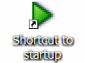

1. Now click on the respective icons to start the servers for the respective applications.

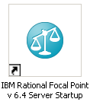 and 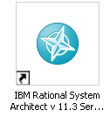

1. If demonstrating System Architect only or System Architect and Focal Point integration then start with System Architect only. On the desktop click on the icon

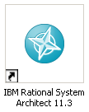

1. With system Architect open make sure that the M&A encyclopedia is open.
2. If demonstrating Focal Point only on the desktop click on the icon

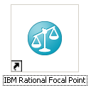

then login to Focal Point with details

* User name: safpdemo
* Password: demo

Step By Step Guide

## System Architect

### Purpose

Enterprise Architecture provides a clear view of how the business and technology resources will support and achieve an organization’s business goals and initiatives. This is achieved by understanding the strategy, the business, the systems, the infrastructure and how they interrelate. Using this Enterprise Architecture helps prioritize and decide which things to do and in what order and govern their development.

### Avoid

There are many utilities that are available that automatically transform models from one form to another. Correct operation of automated functionality is dependent upon having model content populated properly and fully. Avoid running these just in case models are incomplete or have been changed, for example *Dictionary > Export to Use Case Diagram* when in a Business Process diagram.

### Show & Speak

System Architect use the concepts of Encyclopedias and Workspaces to hold model content. A windows explorer type of navigation aid is used to access model content and is referenced throughout the remainder of this document as the Explorer.

1. To use the Explorer go to *View > Explorer.*

* Mention that the Explorer classifies content into Diagrams and Definitions and organizes them into Views

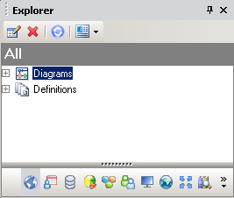

## System Architect: Explorer Diagram

### Purpose

The *Explorer* diagram is a diagram that provides an entry point of view used to perform analyses and illustrate inter-relationships and dependencies of Enterprise Architecture content.

### Avoid

Avoid showing how to create the *Explorer Collections* and *Explorer Reports*; the syntax for these is pseudo SQL and looks technical.

### Show & Speak

1. *Within the Explorer navigator expand the Diagrams section and then expand the Explorer section*

* Existing Explorer diagrams are listed.

1. *Double click on Impact* *Analysis to open the diagram.*

* This models typical Enterprise Architecture components.
* The inter-relationships between the various components are shown.
* Inter-relationships are created automatically and dynamically using reports.

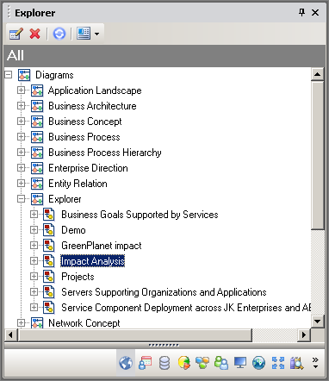

1. *Double click on Reduce Cost of Goods Sold to open the definition.*

* Describe that this is a Business Goal definition that has textual properties and inter-relationships to other model components.

## System Architect: Enterprise Direction

### Purpose

The *Enterprise Direction* – is a diagram that serves to capture the business motivation model and shows the *Ends* that an enterprise wants to attain and the *Means* by which they will get there.

### Show & Speak

1. *Within the Explorer navigator expand the Diagrams section and then expand the Enterprise Direction section.*

* Existing Enterprise Direction diagrams are listed.

1. *Double click on JK Enterprises Corporate to open the diagram.*

* Point out that the *Objectives* model the *End* state that the Enterprise wants to achieve
* Explain that the *Mission*, *Strategy*, and *Tactics* deployed by the Enterprise describe how it is going to achieve its *Ends*.
* Mention that control over the behavior of the Enterprise is exerted by applying *Governance* by way of *Policies* and *Business Rules*.

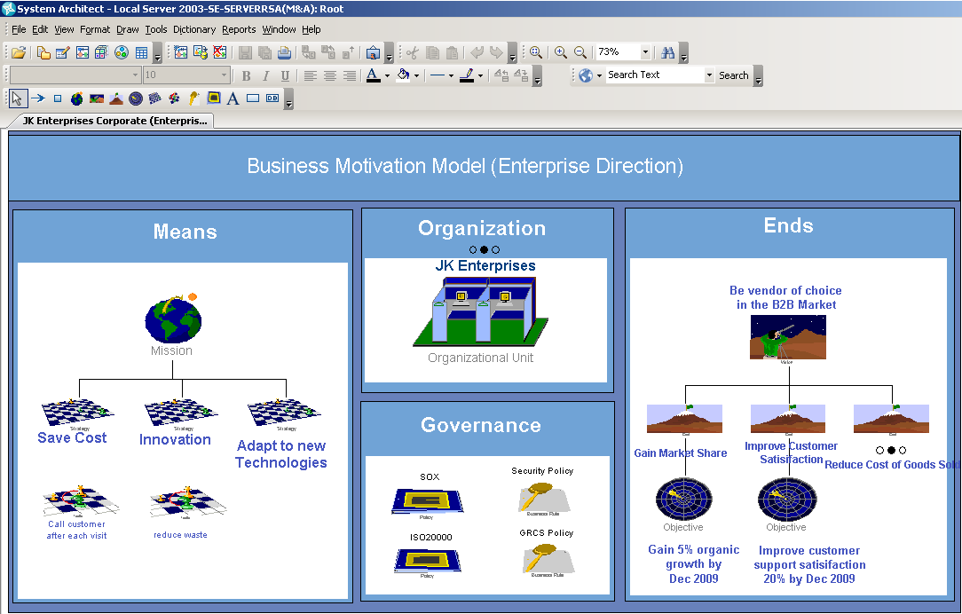

## System Architect: Organizational Structures

### Purpose

An Organizational Unit is a defined subset of your enterprise that exists to perform a specific business purpose and normally has Roles associated with it that perform the tasks. The Organization Chart provides a hierarchical view of the way organizational units are organized.

### Show & Speak

1. *Within the JK Enterprises Corporate Enterprise Direction diagram select the JK Enterprises Organizational Unit symbol.*
2. *Right-mouse click over it, choose Child to navigate to the associated models.*
3. *Select the JKE Corporate Organization Chart diagram.*

* Explain that the organizational structure of the Enterprise is described using *Organizational Units*.
* Point out that the *Organizational* structure is modeled both in a hierarchical and matrix manner.

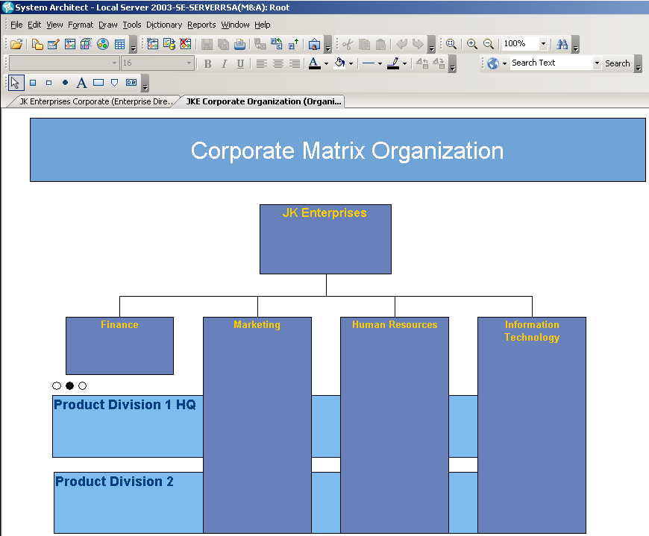

1. Select the *Product Division1 HQ* Organizational Unit symbol
2. *Right-mouse click* over it, choose *Child* to open the detailed Organizational Chart diagram.
3. *Double click on the PD1-Sales symbol to examine it’s content*

* Describe that this is an Organizational Unit definition that has a description and details the Roles that are part of the is unit.

## System Architect: Business Activity Models

### Purpose

Business Process Hierarchy diagrams model the decomposition of business activities in a hierarchical manner.

### Show & Speak

1. *Within the* *Product Division 1 Organization Chart diagram select the PD1-Sales symbol*
2. *Right-mouse click over it and choose Child to navigate to the Business Process Hierarchy diagram named JKE Functional Decomposition.*

* Explain that the Business Process Hierarchy diagram shows what are the activities, in a hierarchical manner, that the business is engaged in.
* Point out that the activities can be decomposed into sub activities
* Each of the leaf activities are decomposed into a process diagram that describes how the activity is performed using a flow type diagram.

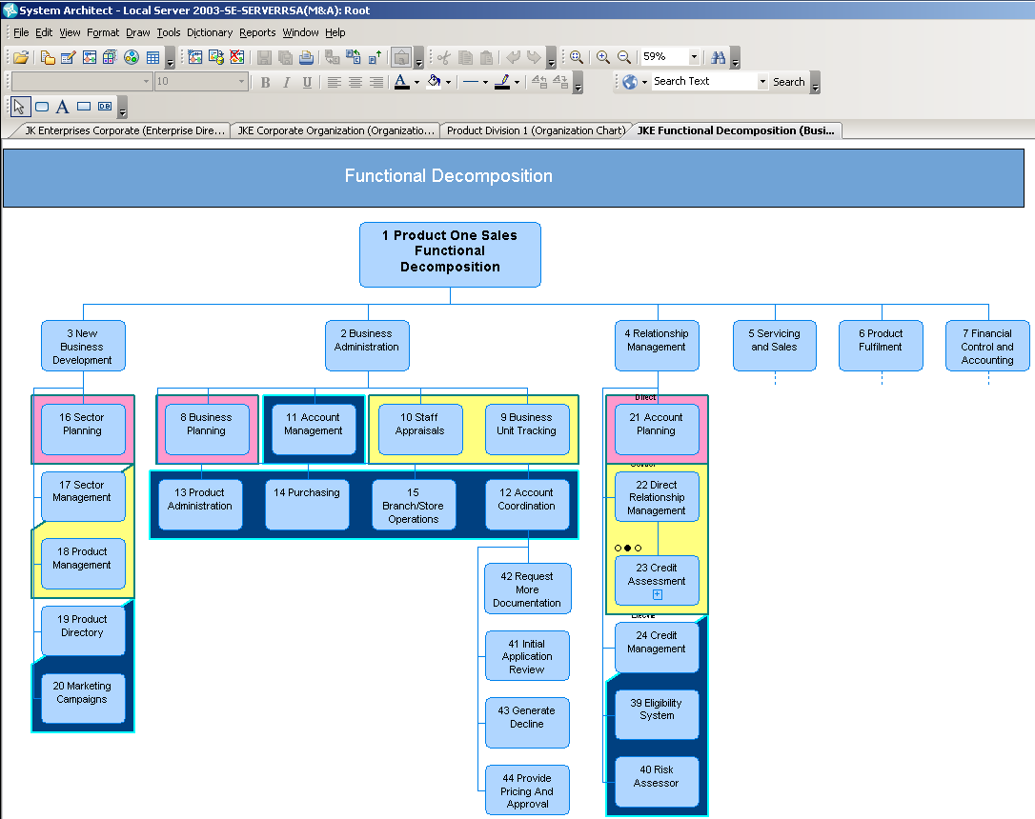

## System Architect: Business Processes

### Purpose

Process models depict the sequence flow, decision making, responsibilities, and the end goals of a performing a series of inter-related tasks.

### Avoid

Avoid talking about the intricacies of the BPMN notation that this used for this diagram. It is suffice to say that this is a process flow diagram.

### Show & Speak

1. *Within the JKE Functional Decomposition diagram select the Credit Assessment symbol*
2. *Right-mouse click over it, choose Child to open up the Sales Credit Business Process diagram.*

* Explain that the purpose of the process diagram is to show various flows paths that can be followed when the business executes these tasks.
* Point out that the Swim lanes represent the Organizational Units modeled in the Organizational Charts.
* Explain that analytic depictions show the state of an aspect of the business process. For example on the *Determine Applicant Eligibility symbol* the costs are relatively high in performing this process as indicated by the gauge.

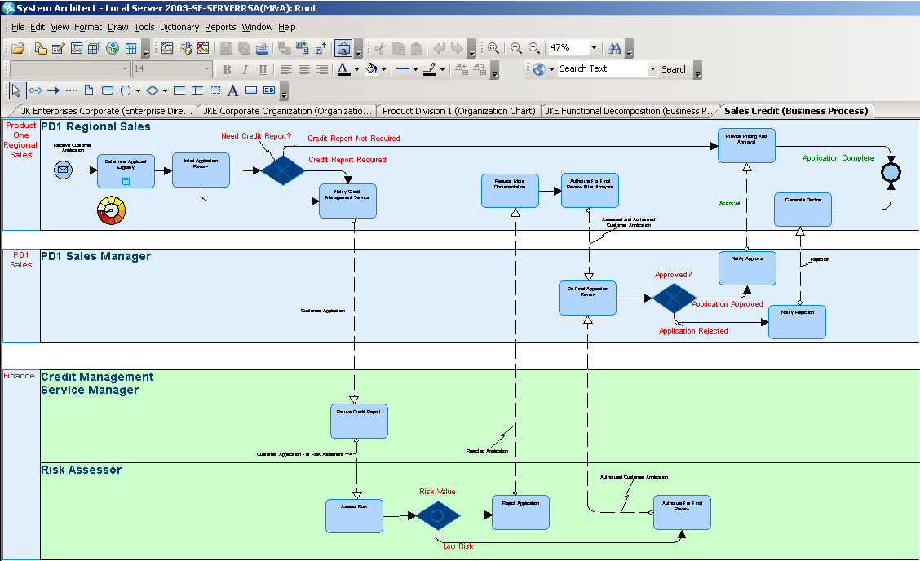

1. *Double click on the Determine Applicant Eligibility symbol.*

* In page 2 of the Analysis chapter, point out the related items such as Entities, Applications, Locations etc. and here is captured the rich set of inter-relationships and dependencies.

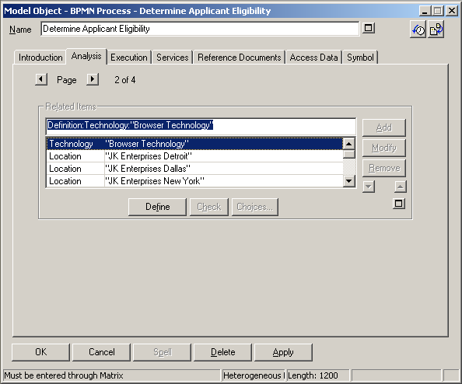

## System Architect: Use Case Models

### Purpose

Use Case models capture how the business conducts, either now or in the future, it‘s work utilizing an IT system. This approach assists in building scenarios that model the functions of the syste.

### Avoid

Avoid using the Business Process to Use Case conversion utility that is available from *Dictionary > Export to Use Case*.

### Show & Speak

* Explain that Use Cases can be generated automatically from Business Process diagrams by virtue of their relationships to Roles.

1. *Within the Sales Credit Business Process diagram show, but don’t do, the menu from Dictionary > Export to Use Case.*
2. *Select the Determine Applicant Eligibility symbol.*
3. *Right-mouse click over it and select Child to open up it’s Verify Account Use Case model diagram.*

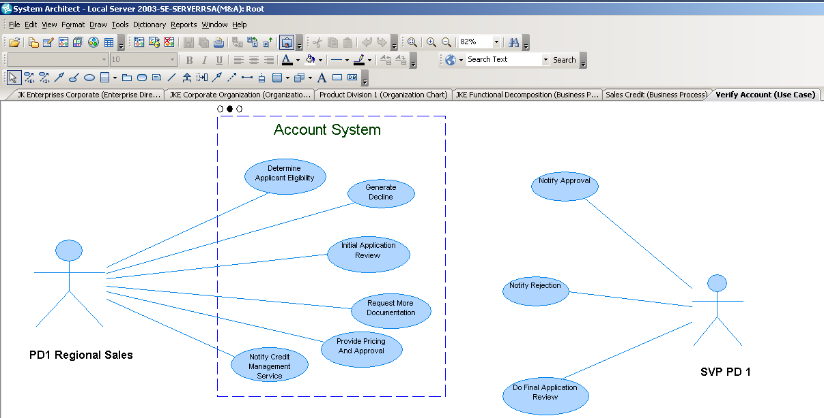

* + Explain that these Use Cases describe the interactions of the various actors with the system to determine the applicants eligibility for credit.

## System Architect: System Architecture

### Purpose

The System Architecture Diagram graphically model the Applications of a System, the Externals that they interface with, the data stores that they use, and the flow of data through interfaces between the Applications.

### Show & Speak

1. *Within the Verify Account Use Case diagram right-mouse click over the Account System symbol*
2. *Choose Child to open up the Sales Processing System Architecture diagram.*

* Explain that this models the systems interfaces, applications, and flow of data.

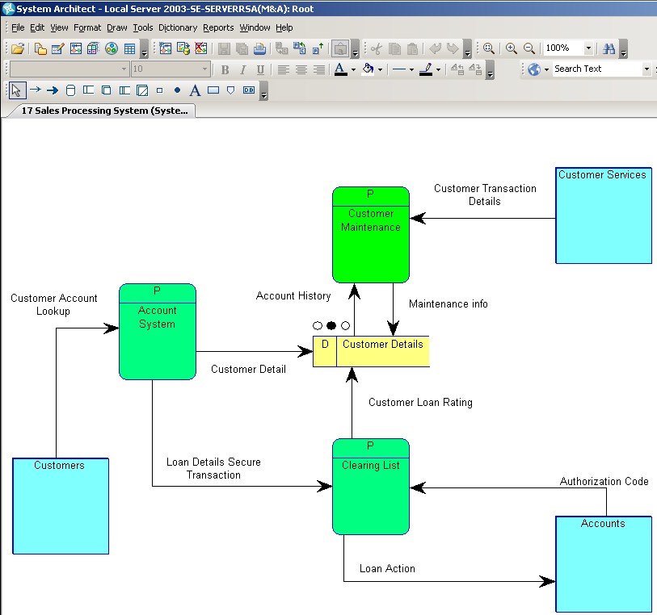

## System Architect: Information Models

### Purpose

Logical data models are graphical representation of the information needs of importance to the enterprise and show how they relate to one another.

### Show & Speak

1. *Within the Sales Processing System Architecture diagram right mouse click over the Customer Details symbol*
2. *Choose Child to open up the* *Sales Processing System Update Entity Relation Model.*

* This shows the logical data and their relationships to other entities from the Sales System Processing point of view.

1. *Double click on the Order entity symbol to view the details.*

* Explain that this shows the data attributes that define the logical entity

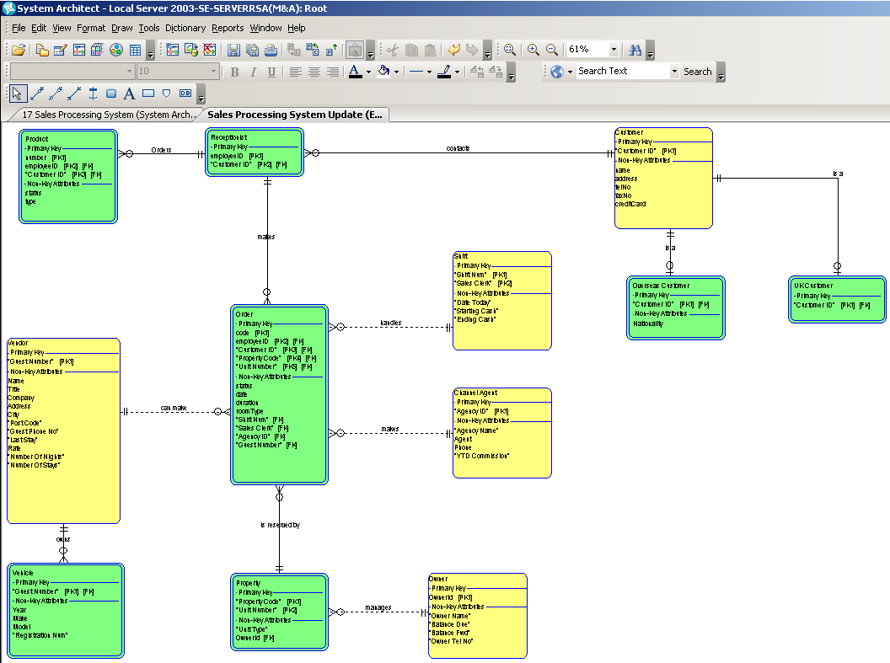

## System Architect: Infrastructure Models

### Purpose

The Network Concept Diagram is a high-level diagram that is used to model the enterprise’s network infrastructure. It depicts the conceptual nodes and their inter-connections within the overall network. It includes such information as the types of communication lines in, the connection points, hosts, and servers.

### Show & Speak

1. *in System Architect go to Window > Close All.*

* This is a quick way of closing all of the model views in one easy step, don’t save any changes to the model contents if prompted.

1. *Go to the Explorer and open up the Network Concept section in the Diagrams division, and open up the Server Portfolio diagram.*
   * A highly visual representation of the Infrastructure that supports the Enterprise is displayed.
   * Open any one of the Server symbols, show that the *Server* definitions have comprehensive textual properties and inter-relationships to other model components.

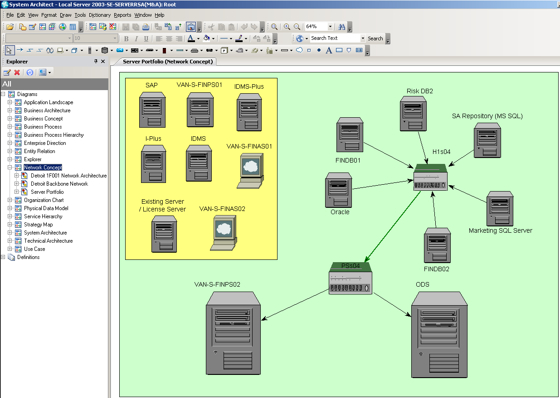

## System Architect: Strategies and delivering Projects

### Purpose

Remember that the *Business Motivation* that was captured in the *Business Enterprise diagram* showed the specific *Strategies* that the enterprise was going to adopt to help it achieve it’s *Ends*. Remember that *Projects* are created in order to deliver as per the *Strategies*; the *Explorer* diagram illustrates these inter-relationships.

### Show & Speak

1. *Go to the Explorer and re-open the JK Enterprises Corporate Direction diagram*.
   * Recap the *Strategies* that are modeled.
2. *Go to the Explorer and open up the Explorer section, and open up the Projects diagram.*
   * Explain that the *Explorer* *Diagram* visually draws attention to *the Projects* and their relationships to other model components
   * Highlight that in particular we are interested in the *Strategies* that are related to *Projects* as shown in the diagram.

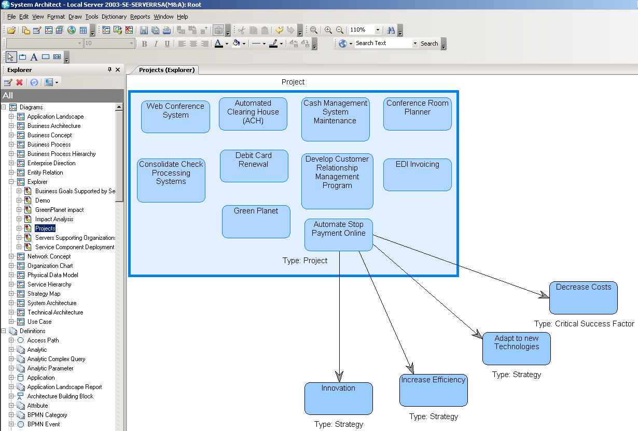

1. *Show, but don’t run, the Tools > Focal Point menu entry*
   * Point out that the integration pushes out *Projects* as *Projects* and *Strategies* as *Criteria* into Focal Point.

## Focal Point: New Project Proposals

### Purpose

The integration enables the users to move projects, applications and criteria, which in this case are the strategic objectives, from System Architect over to Focal Point.

### Avoid

Avoid showing the technical pieces of the integration as such, considering that the audience is most likely not technical. Wait until asked to show how the integration actually works.

### Show & Speak

1. Open the *IT Portfolio Management Demo v1.0* Focal Point Workspace. Workspaces provide a means of organizing different project portfolios.
2. *Go to Display > Project Proposals.* 
   * The list of new projects is displayed.
   * These are the same projects as in System Architect.
   * You can see which application they are associated with.
   * The workflow at the top shows which transitions can be made when the project is in proposed state.
     1. *Accept* if the project proposal seems valid. Once accepted an owner will do further assessment and create a business case for it, thus preparing the proposal for value analysis.
     2. *Business Requirement* if not a project, but rather a request on existing application or product. The proposal ends up in a separate process for business requirements, that later can become part of the scope of an approved project.
     3. *Backlog* if it’s in fact not a project, e.g. defect, support case etc. Backlog items should be handled by other systems and follows a separate process.
     4. *Duplicate* when there is already a similar project.
     5. *Clarify* if the description of the proposal is too vague
     6. *Reject* if the project does not seem valid.
   * Accepted projects are assessed by an owner who creates the business case for the project. But before it can be approved for implementation we need to do value analysis.
3. Click on Accept for one of the projects to show how you can select the owner and write some comments as the project proposal is transferred to the next state.

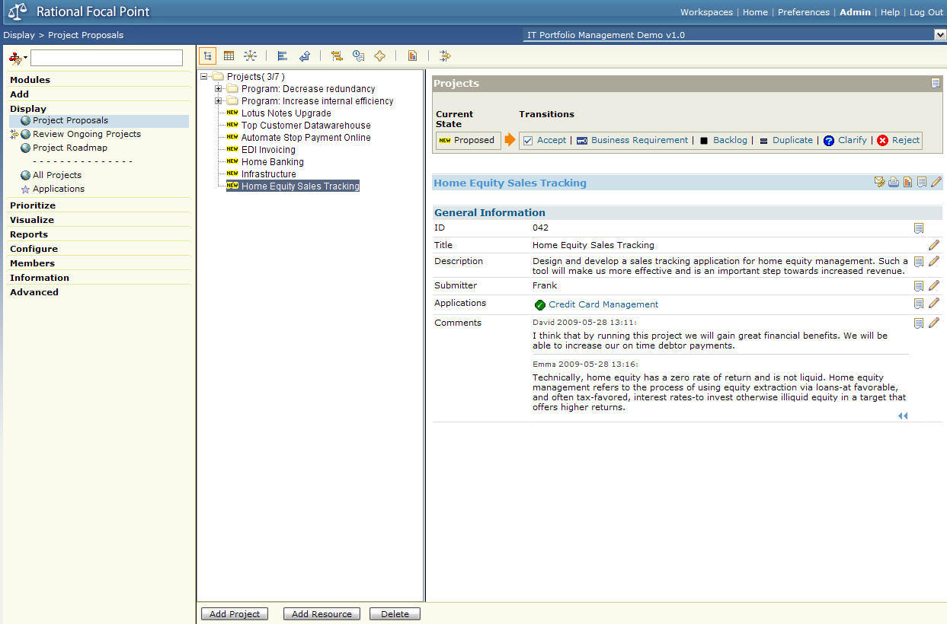

## Focal Point: Value Analysis

### Purpose

The value analysis capability of Focal Point is unique and provides with crucial and very valuable information that turns decision-making into something objective rather than subjective. Focal Point helps you determine how to optimize the value of your project portfolio.

### Avoid

Avoid speaking about or showing the other types of visualizations, e.g. XY chart, stacked bar chart, pie chart etc.

### Show & Speak

* Explain that pair-wise comparison has already been performed to for expediency, but show an example of how this is done.

1. *Go to Visualize > Strategic Objectives.*

* We have 5 strategic objectives; *save cost, innovation, adapt to new technologies, increase efficiency* and *manage change*.
* They are not equally important, *save cost* is most important for us, then comes *innovation*. The weight we have used here will influence our project portfolio to include only those projects that support the most important strategic objectives the most.

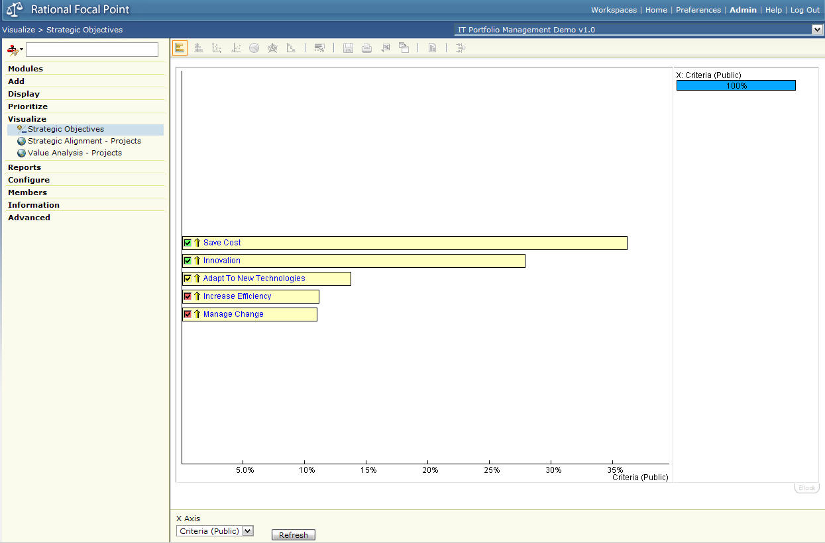

1. *Go to Visualize > Strategic Alignment – Projects.*

* Here we see how much our project proposals are aligned with our strategic objectives in a prioritized order.
* The weighting of the strategic objectives that we saw before is also considered when creating this ranked list.
* Projects that are most aligned with our strategy are in this case ‘Automate Stop Payment Online’, ‘Infrastructure’ and ‘Home Equity Sales Tracking room’.
* But it’s also important to consider other aspects than only strategic objectives before we make our final decision on which projects to approve for implementation.

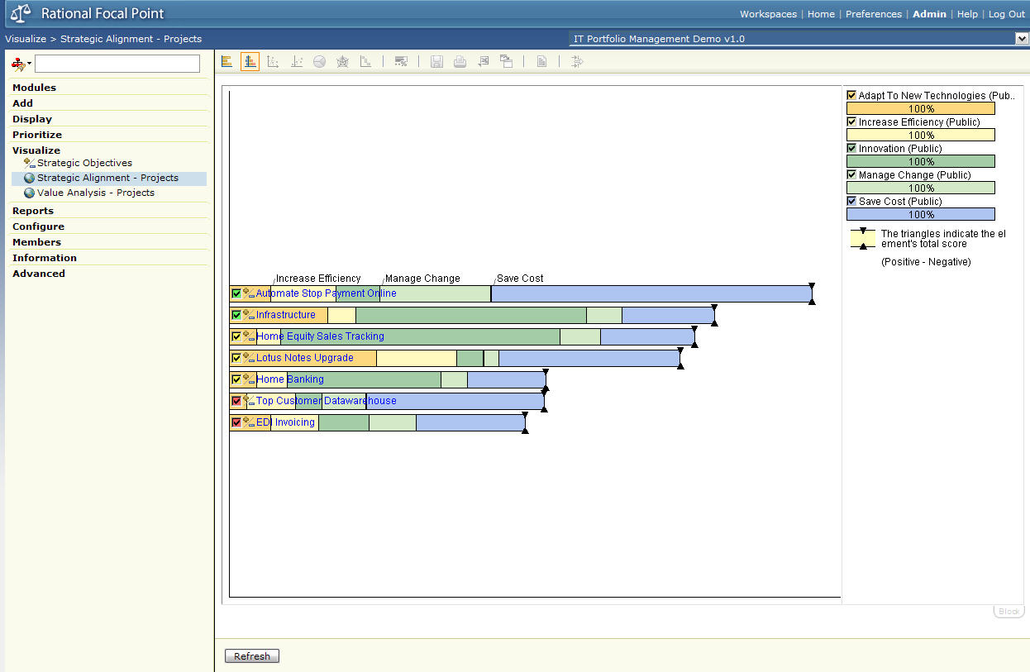

1. *Go to Visualize > Value Analysis – Projects.*

* Here we have also included Risks, Payback Period and NPV in addition to alignment with the strategic objectives.
  + The risk score is a calculated number based on probability and impact for each risk associated with the project.
  + Payback period is defined as the number of months needed to return on investment.
  + NPV is the Net Present Value and is defined as the total present value of a time series of cash flows or, as used in this demo, estimated result considering benefits and expenses associated with the project. An earned dollar today has higher value than an earned dollar tomorrow. The purpose of NPV is to be able to determine profitability with regards to internal rate. Thus, the NPV should be as high as possible.
  + The score for strategic objectives has been summed up from the previous screens, still considering the weight of each strategic objective.
* Now ‘Lotus Notes Upgrade’ is the top-scoring project with a very high NPV, followed by ‘Automate Stop Payment Online’, ‘Home Equity Sales Tracking’ and ‘Infrastructure’.
* ‘Infrastructure’ does not seem to have a positive NPV. Maybe it’s not a good idea to go ahead with that project?
* To sum up, we should go ahead with the projects that provide the highest value (in this case highest NPV and highest alignment with strategic objectives) to the least possible risk and with the shortest payback period.

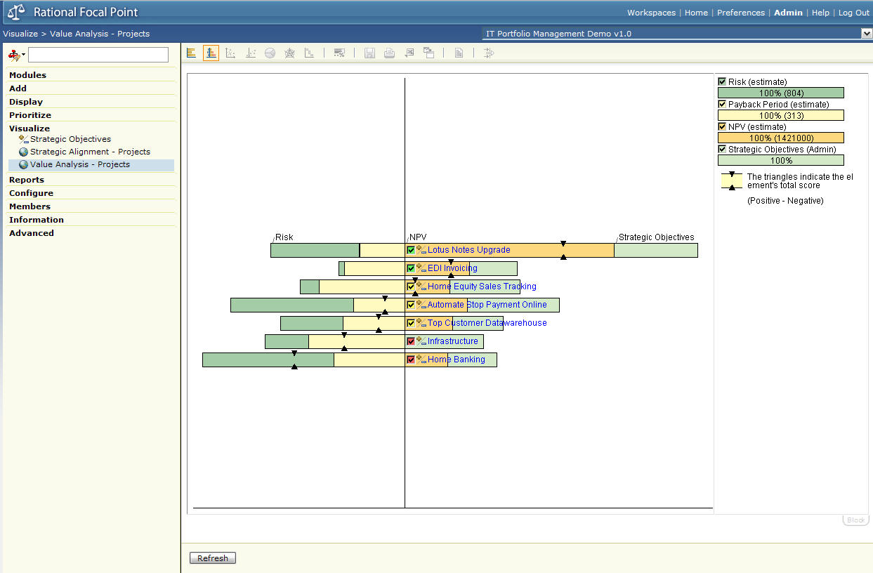

* But what is the optimal set of project to implement based on this result? Which projects do we not include? Focal Point supports what-if analysis to help you understand this.

1. *Deselect the red projects in the chart, i.e. the bottom two*.

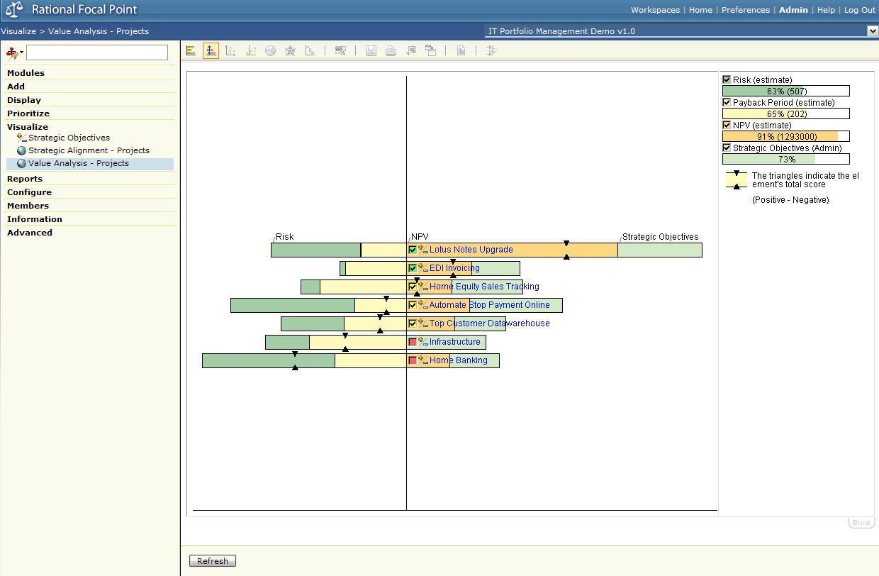

* If we choose not to do the last 2 projects, we reduce risk by 50%, while still maintaining 80% of NPV, 75% of payback period and 70% alignment with our strategy. Note how Focal Point shows you the NPV value in parenthesis as you select and deselect projects. If you do all projects in the list your NPV will be $1421 000, and if you don’t do the last 2 your NPV will be $1293 000.
* You can continue selecting and deselecting projects to reach your budget or other limitations and thresholds that you might have.
* This information is very useful for us in our decision-making.
* So now that we have picked the projects that provide the most value for our portfolio, we need place them in our project roadmap to see when in time it would be most optimal to carry them out.

## Focal Point: Roadmap & Planning

### Purpose

The Gantt chart in Focal Point is used to create roadmaps, i.e. a visual plan with a time scale. It provides a framework to help plan and coordinate projects to be started and finished at the right time considering other projects in the pipeline, available resources and budget.

### Avoid

Avoid displaying too many links and too many dates at once in the chart. That will only make the chart cluttered and more difficult to understand.

### Show & Speak

1. *Go to Display > Project Roadmap*.

* Here are projects that have been approved for implementation in a roadmap chart.
* At the bottom is a time scale. The dotted vertical line represents today’s date.
* The bars in the chart indicate the duration of the project starting with a light blue diamond as the symbol for the start date and a green flag as delivery date. In between are milestones for concept, implementation and end dates.

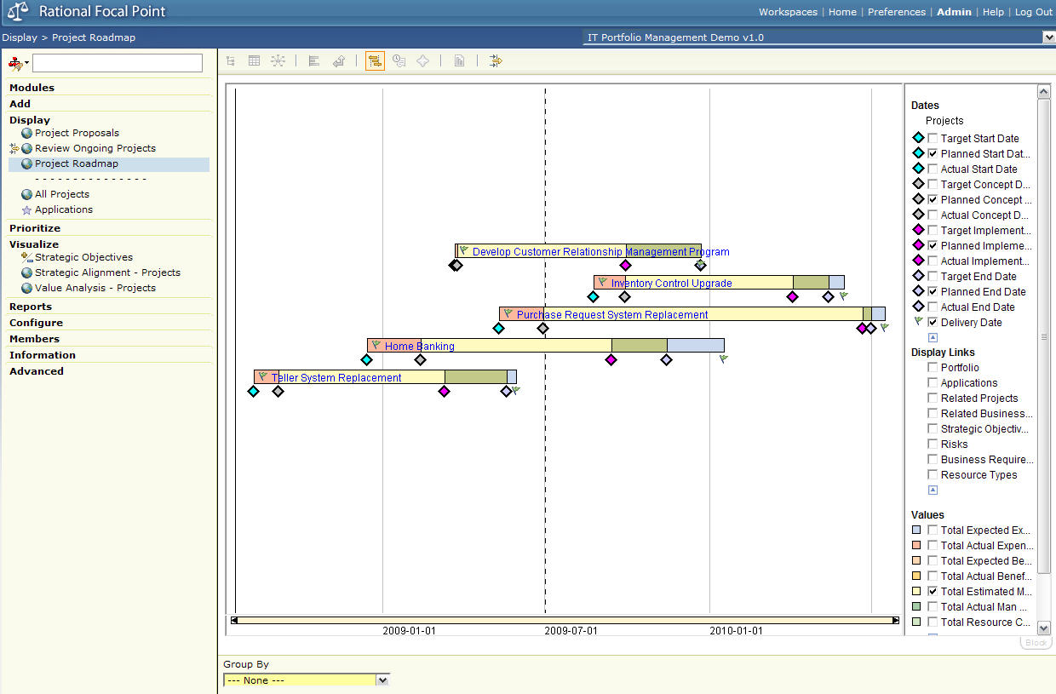

1. In the Group By dropdown list in the bottom frame, select *Expected Expenses*.

* The total expected expenses are now shown on the left side and the projects have been re-ordered; cheapest project comes first ($719 000)and most expensive project comes last ($6262 000).

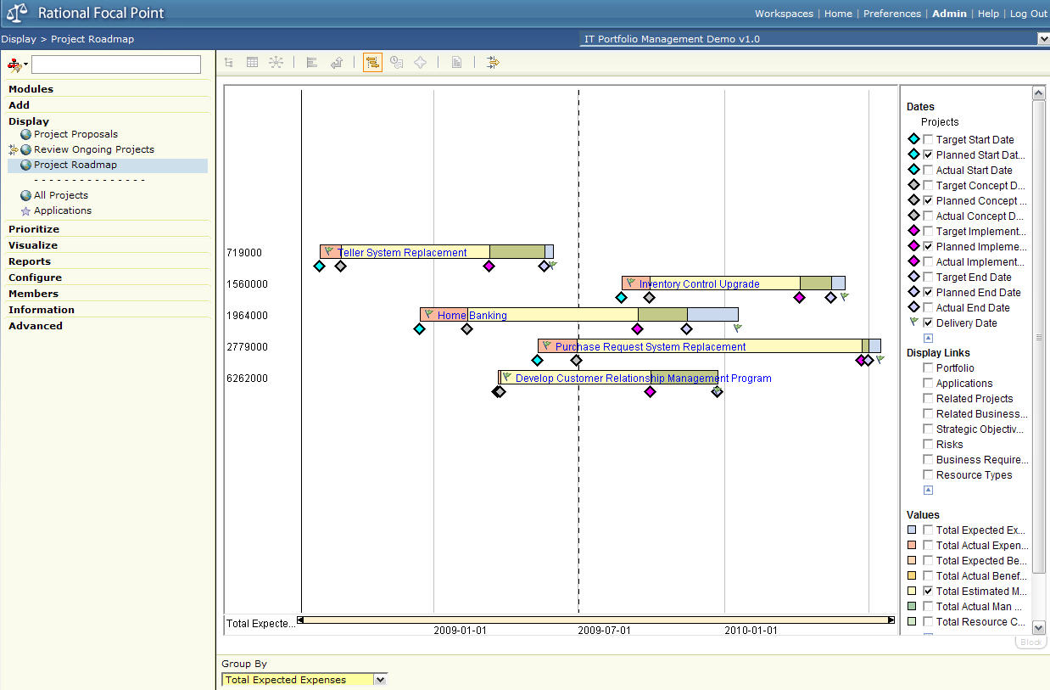

1. *Check the Business Requirement box under Display Links*.

* The business requirements are the scope of the project.
* The chart is now updated to show the business requirements associated with each project.
* Drill down to details about a certain project or business requirement by clicking the links in the chart.

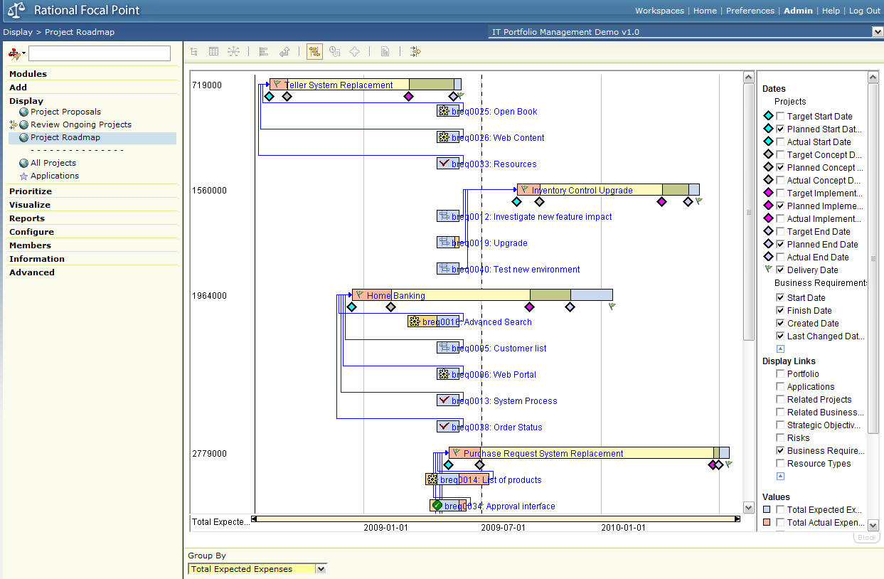

1. *Uncheck the Business Requirement box to hide the links to the business requirements*.
2. *Right-click in the chart and select Size of Value Area – Medium*.

* The histogram in the bottom frame indicates the estimated man hours associated with the projects over time.
* We now see how many man hours we expect to use in the projects over time. You need to have an understanding of the resources you have available and make the histogram represent that as much as possible. Focal Point lets you do what-if analysis in this chart too, where you can move the projects back and forth in time until you are satisfied.

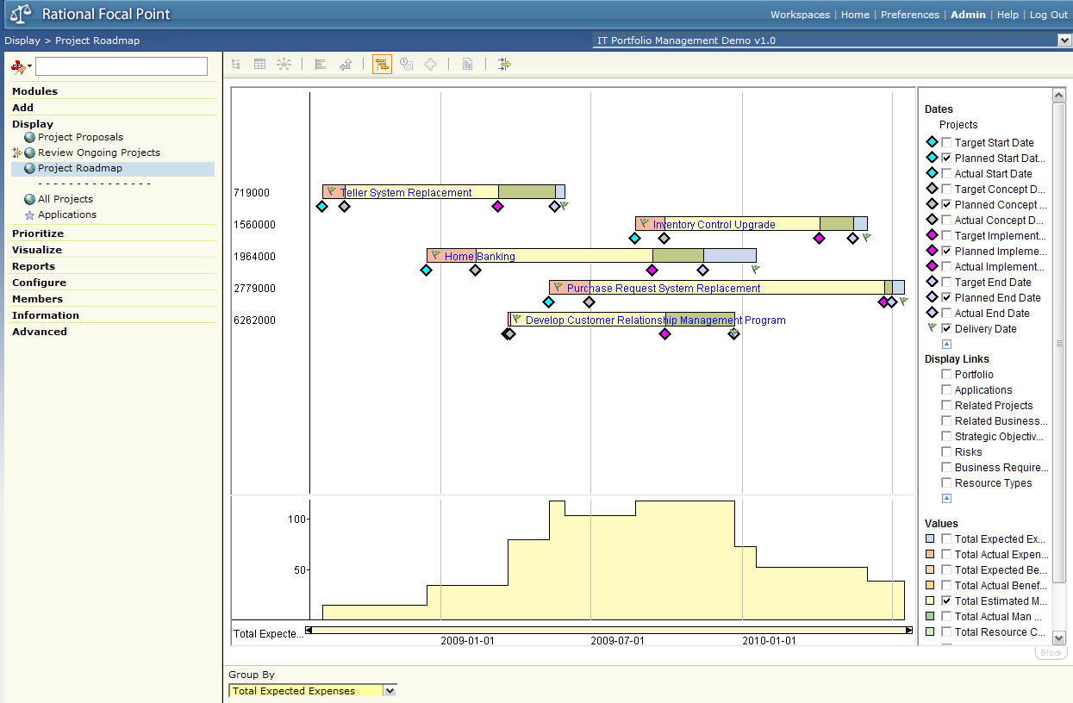

1. *Click the Edit button in the right frame*.
2. *Drag the projects back and forth in time*.

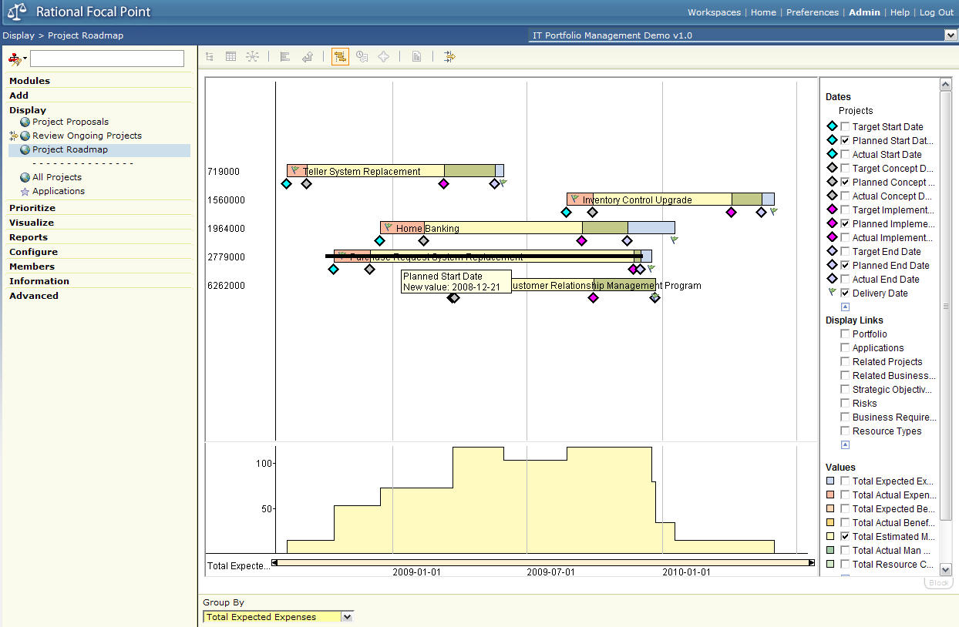

* The estimated number of man hours change automatically.
* This way you can optimize your project schedule.
* Once the project roadmap has been determined the projects implementation can be started according to schedule. What is important from a project portfolio perspective is now to monitor progress of the projects as well as performing regular reviews of the portfolio.

## Focal Point: Review & Monitor

### Purpose

Reviewing and monitoring project progress and health is central in the portfolio management domain. It should be easy to find those projects that, for example, are not progressing according to schedule or those where actual cost exceeds estimated cost to a high extent. It’s also of importance to review and monitor on portfolio level to ensure that each portfolio performs well. Focal Point can help you do this.

### Avoid

Avoid showing the *Review Ongoing Projects* view without any filter active. Avoid also showing the export function that is available in this view as this takes focus away from the subject.

### Show & Speak

1. *Go to Display > Review Ongoing Projects. Select filter Overall.*

* Let’s review our portfolio of ongoing projects to see whether or not we have any problems.
* The ‘Overall’ filter gives a general overview of the projects;
  + Name of the portfolio they belong to
  + Implementation state
  + Which strategic objectives do the projects align with?
  + What’s the total risk score?   
    The risk score is calculated as impact multiplied with probability.
  + What’s the NPV associated with the project? That gives an indication of how valuable it is for us financially.
  + Is the implementation of the project scope, i.e. the business requirements, on target or not? If there are business requirements that are not moving ahead as planned you would get a warning or red light.
  + Is the project is progressing according to schedule or not? If there are any major differences between target, planned and actual dates you would get a warning (yellow light) or red light meaning you need to take action.
* For each of link it’s possible to drill down, so you could for example open up details on the project, the portfolio or the strategic objectives.

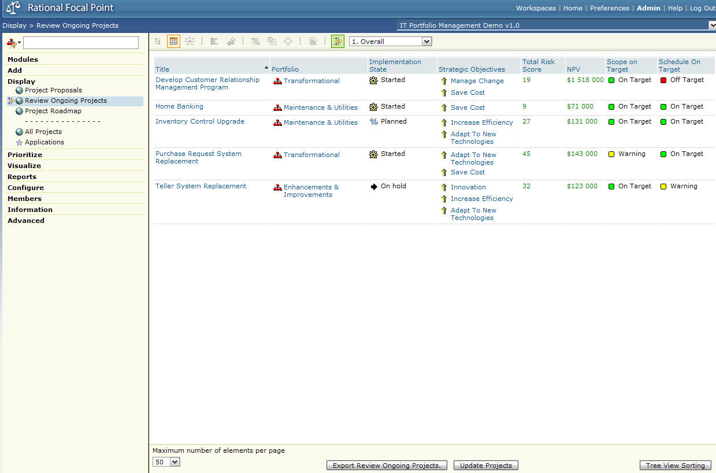

1. *Change to filter Business*.

* The ‘Business’ filter gives an overview for the business audience;
  + Who is the owner of the project, i.e. who drives it through the process?
  + Which applications are the projects associated with?
  + Which strategic objectives do they align with?
  + What’s the total risk score?
  + What are the business requirements, i.e. the project scope, that have been included in the project? The icon in front of the title of the business requirements indicates its state. For example you have planned, started, to be tested and completed.

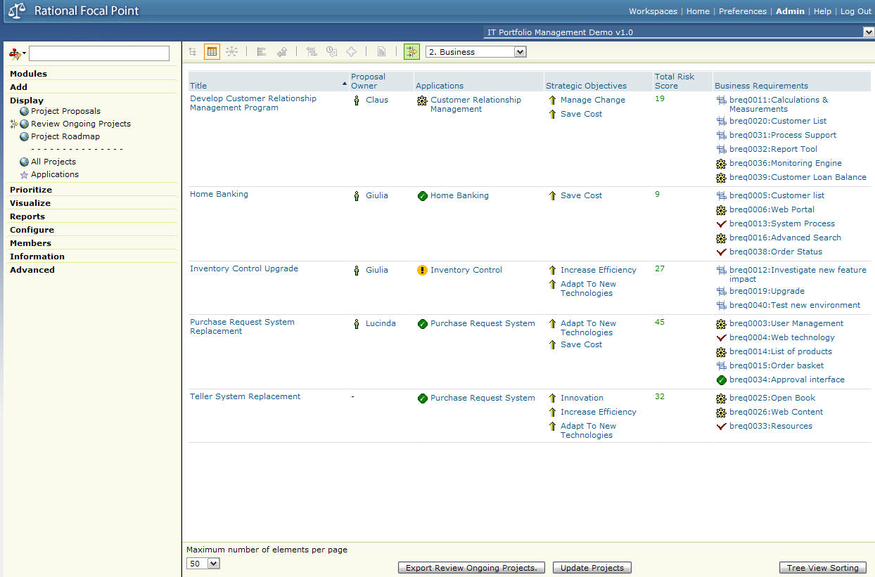

1. *Change to filter Cost*.

* The ‘Cost’ filter gives a financial overview;
  + NPV
  + ROI where 100% is break-even.
  + What are the total expected and actual expenses?
  + What are the total expected and actual benefits?

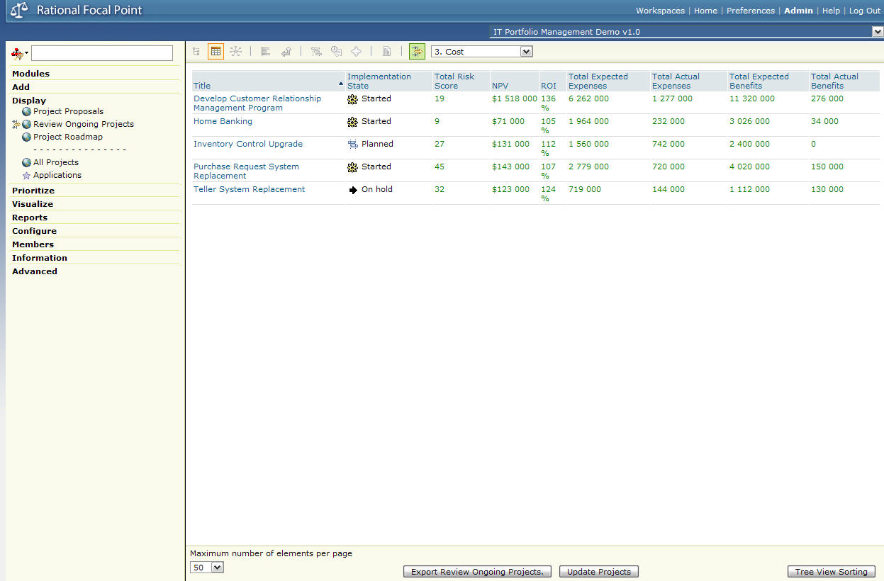

1. *Change to filter Schedule*.

* The ‘Schedule’ filter gives an overview on how the projects are progressing;
  + Are we on target with regards to the scope?
  + How many hours have been spent already on the project compared to the number of hours we have available?
  + How long will the project last?
  + Is the project progressing according to schedule?
  + What start and end dates do we have?
  + What’s the delivery date?

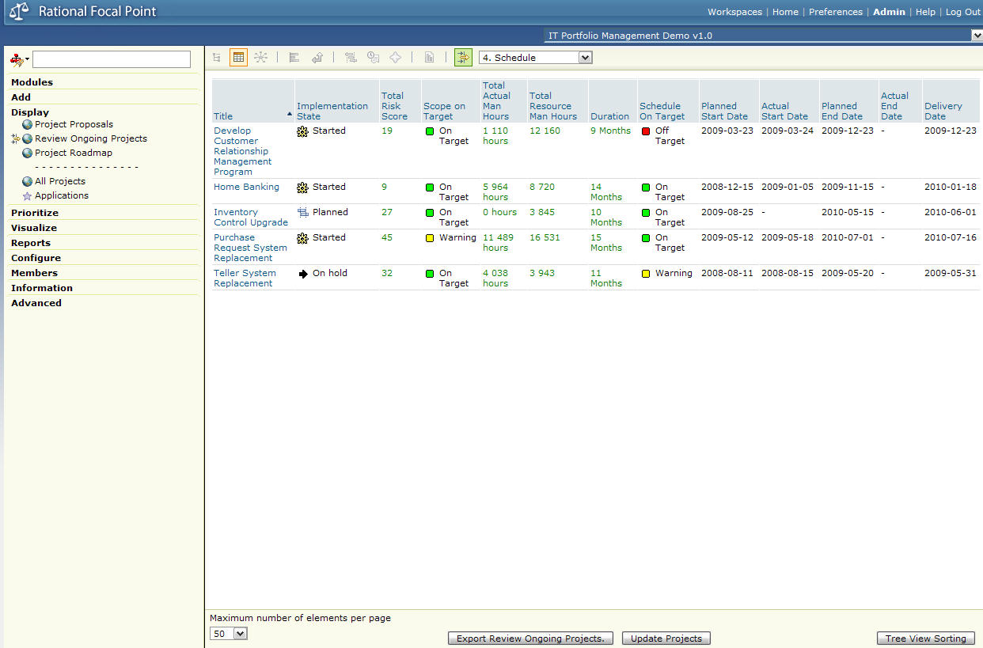

1. *Go to the homepage*.

* Let’s now do a review on portfolio level.

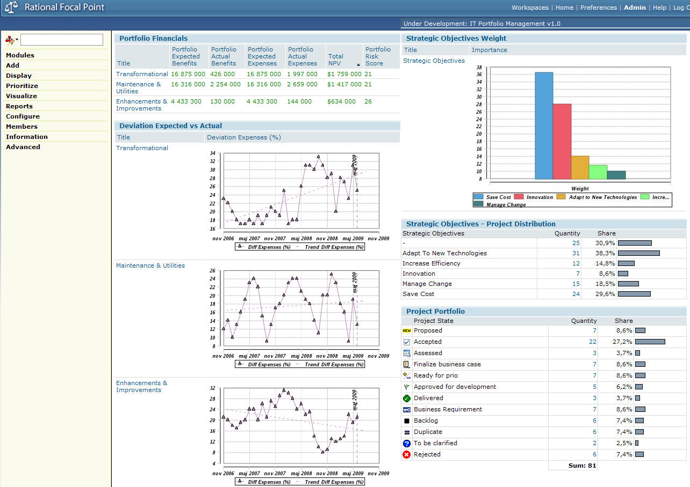

* On the upper left side of the homepage there are some financial information on portfolio level;
  + Expected and actual benefits
  + Expected and actual expenses
  + Total NPV for the whole portfolio, i.e. the NPV for all projects in the portfolio has been aggregated up to the portfolio level.
  + Portfolio Risk Score, i.e. the risk score for all projects in the portfolio has been aggregated up to the portfolio level and then we’ve used the average of that value to be able to compare with other portfolios.
* On the lower left side of the homepage are graphs of deviation (%) for actual versus expected expenses over time. Around 20% deviation is considered normal. The trend lines in the charts give an indication of what the deviation will be in the future.
  + The ‘Transformational’ portfolio has an increasing trend which needs to be dealt with. We must not allow this trend to continue.
  + The ‘Maintenance & Utilities’ portfolio trend line looks pretty stabile, but it varies a lot from month to month.
  + The ‘Enhancements & Improvements’ portfolio has had a high variance historically, but is decreasing. This portfolio was doing bad but is doing well now.
* On the upper right side is a graph of the weight of the strategic objectives. This is another representation of how we have valued our objectives.
* On the middle right side are the projects distributed on strategic objectives to give an indication of how many projects support a certain objective. A target could be to have a distribution that is similar to how the strategic objectives have been weighted. Right now we have only 7 projects supporting the Innovation objective while we still consider this objective to be second most important for our business. Maybe we need to take action here?
* On the lower right side are all projects distributed on state to give an indication of how many projects are in the pipeline, how many projects are being executed currently etc.

# Anticipated Questions

## How does the integration work?

### Purpose

The purpose of the integration is to export data and criteria from System Architect into Views in Focal Point. The content that is exported is specified as part of report query.

### Show & Speak

1. To review the existing content in *Focal Point* login with details

* User name: admin
* Password: focalpoint

1. Open the *IT Portfolio Management Demo v1.0* Workspace
2. Go to the *Modules* and open the existing *Criteria* (Strategy definitions)

* Point out the list of existing *Strategic Objectives*

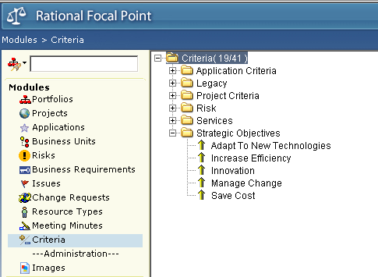

1. Go to the *Projects* module

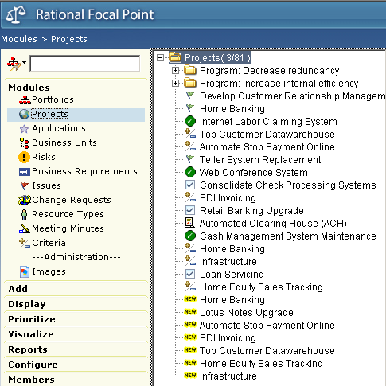

* Point out the list of existing *Projects*

1. Log out of Focal Point after reviewing the content
2. Explain that the content that gets pushed into Focal Point depends upon the selection parameters specified as part of the reports used.

* To learn how to create new export profiles, see the question *How do you create a new Focal Point profile?*

1. From System Architect Click on *Tools > Focal Point…* to start the export process.
2. Use the *admin/focalpoint* credentials to login and specify the Focal Point server address as <http://localhost/fp/services>
3. To send data using an existing profile select *send data from a previously saved Focal Point* and select *SA FP Demo*
4. Click on *Export* to transfer the data.
5. Log back into Focal Point using the credentials *admin/focalpoint*
6. Review the *Projects* exported from System Architect, notice that they are marked as *“New”*
7. Review the *Criteria* (Strategy definitions)

## How do you create a new Focal Point profile?

### Purpose

Focal Point profiles are created to facilitate the export of content from System Architect to Focal Point they are used to specify

* What content (data and criteria)
* Locations (views) where the content is to be stored in Focal Point
* Define the mappings between the properties in System Architect and the attributes in Focal Point

### Show & Speak

1. From System Architect Click on *Tools > Focal Point…* to start the integration dialog
2. Login with details

* User name: admin
* Password: focalpoint
* Note that it is not necessary to login as the administrator as long as the user has access rights to the relevant views.

1. Click on *Create a new Focal Point profile* to create and name a profile

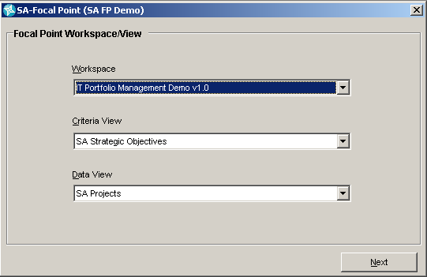

1. Specify the target Workspace from the drop down list
2. Specify the *Criteria View* (the view that holds the criteria that is to be applied to the data content)
3. Specify the *Data View* (the view that holds the content being evaluated) from the drop down list.
4. Click on *Next* to proceed to the next stage

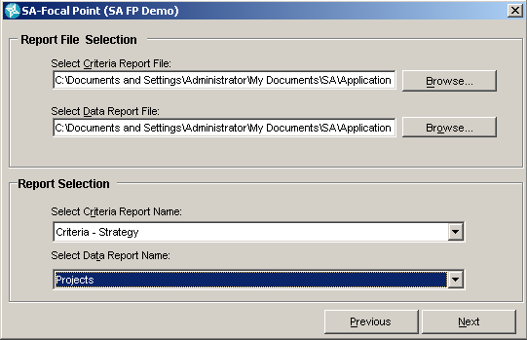

1. Select the *Criteria Report File* and *Data Report File* that contain the queries to be used for exporting content, see the path *“C:\Documents and Settings\Administrator\My Documents\SA\Application Portfolio Management.RPT”*
2. Select the *Criteria Report* *Name* and the *Data Report Name*, these reports specify the query to use to select content from System Architect to be sent to Focal Point
3. Click on *Next* to proceed to the next stage
4. Map the *System Architect properties* to their equivalent Focal Point attributes by selecting a System Architect property from the left hand side, its Focal Point Attribute mapping on the right and clicking on the “Map” button

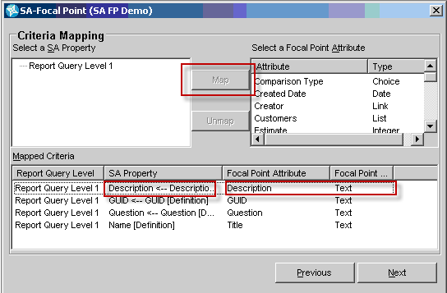

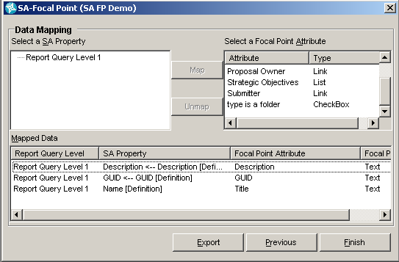

The following are a minimum set of mappings that should be specified

|  |  |
| --- | --- |
| **System Architect** | **Focal Point** |
| GUID | GUID |
| Name | Title |
| Description | Description |

1. Click on *Finish* to complete the creation of the profile

## How do you create a report to use in a Focal Point profile?

Focal Point profiles use reports that are created in System Architect. To create reports that select the definition type and the properties to be mapped.

1. From *System Architect* Click on *Reports,* and then *Report Generator*  to open the report generator dialog
2. Click on *File*, and then *New Report File* to start the creation of the profile

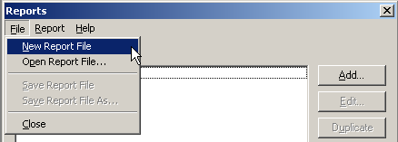

1. Click on *Add*, and then make sure that the report type is specified as HTML, for example

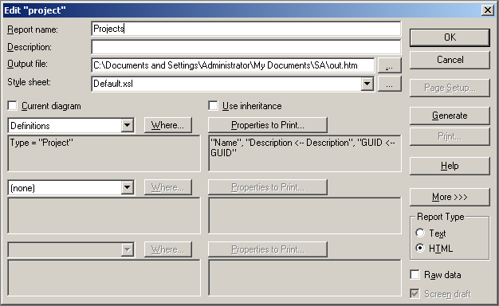

## How do you add data to Focal Point?

[*Avoid showing this.*]

Capturing information is easy in Focal Point and can be done in several ways:

* Single: Use the Add form in Focal Point.
* Multiple: Data can be added through powerful Excel import.
* Automatic capture: Users can send emails that automatically will be imported as new ideas into Focal Point. Attachments included.

[*If still asked to show how this can be done, show only Add > Project, but press Cancel*]

## What is NPV?

* An earned dollar today has higher value than an earned dollar tomorrow.
* The purpose of NPV is to be able to determine profitability with regards to internal rate.
* In detail, NPV is a standard method for using the time value of money to appraise long-term projects. Used for capital budgeting, and widely throughout economics, it measures excess or shortfall in present value terms, once financing charges are met.
* NVP stands for Net Present Value and is defined as the total present value of a time series of cash flows or, as used in this demo, estimated result.

## How is the evaluation done?

1. Go to Prioritize > Strategic Alignment - Projects:

* The projects are compared in pairs, one pair at a time, one criterion at a time
* Once the number of recommended comparisons has been reached, you move on to the next criterion.
* Focal Point also supports the use of estimates (fixed numbers/values) when the criterion is quantitative rather than qualitative. Examples are NPV, Risk Score, and Payback Period.
* Criteria can be weighted for situations where they are not of equal importance.

## What happens after the evaluation?

*[Avoid showing this.]*

Status is changed for the approved project proposal from Ready for prio to Approved for development. Scoping and scheduling is done and the project is moved to a project management tool for execution. Users of Focal Point monitors the progress of the project execution by looking at thresholds and status (see section Focal Point: above). IBM will release a new project management tool that will be integrated with Focal Point to support this.

## Is it possible to rollback the state in case you have made a mistake, e.g. transferred the wrong project to Rejected?

Yes, but only on attribute level. You cannot rollback a whole transition with all its additional changes in one go. You will have to rollback state + additional attribute changes one by one.

## How is an application defined in Focal Point?

1. Go to Display > Applications > EDI
   * Application: Unique Id, Title and Status.
   * Description: Application Description, Comments (threaded discussion), Attachments, Owner, Business Units, Department, Sponsoring Organization, Business Value & Benefits.
   * Application Dates: Proposed Date, Approved Date, Purchase Date, Service Date, End of Service Date.
   * Usage: Number of Purchased Licenses, Number of Deployed Licences, Usage (%) (deployed in relation to purchased), Remaining Usable Time (months) (End of Service Date – Today’s date)
   * Scorecard: Satisfaction Level, Liability, Reliability, Availability, Architectural Fit, Total Score, Criticality.
   * Costs: Yearly Maintenance Cost, Hardware Cost, Perpetual Licence Cost, Yearly Rental Cost, Total Application Cost.
   * Links: Projects (all), Ongoing Projects, Business Requirements, Risks.
   * Technical Details: Location, Application Technologies, Maintenance Window, Service Level.

Attributes are easily configured and added to capture all the data needed to be captured and can be linked to projects, portfolios, business requirements, risks etc.

# Appendix

Table of syntax definitions for System Architect and FocalPoint and their mappings

## System Architect

|  |  |
| --- | --- |
| **System Architect** | **Focal Point** |
| Encyclopaedia/Workspace | Workspace |
| Definition | Module |
| Symbol | *Module – but not recommended* |
| Diagram | Module |
| Any instance of a Definition, Symbol, Diagram | Element |
| Property | Attribute |

## System Architect to Focal Point Mapping

|  |  |
| --- | --- |
| System Architect | Focal Point |
|  | ID |
|  | GUID |
|  | Title |
|  | Description |

## Summary Outline

Use Shortcut to startup to start the SQL server, then start SA using the M&A Encyclopedia

### SA Demo

1. Explorer provides different stakeholder viewpoints and view to address specific concerns
2. Show Explorer🡪Impact Analysis – summarize line-of-sight traceability from business strategy to deployed solutions showing how business and technology support the achievement of business goals

* SA helps identify different opportunities and solutions
* FP helps determine which ones to do and when through tradeoff analysis and prioritization

1. Show Explorer🡪Enterprise Direction🡪JK Enterprise Corporate
2. Select JK Enterprise Organizational Unit and show JKE Corporate Organization child
3. Select Product Division 1 HQ Organizational Unit and show child to see details
4. Show details of PD1-Sales Organizational Unit
5. Show PD1-Sales child JKE Functional Decomposition process hierarchy which describes the responsibilities of this organizational unit
6. Show Credit Assessment child Sales Credit to show the details of this business operation

* Swimlanes represent organizational units
* Analytic depictions display show high cost of Determine Application Eligibility

1. Show details of Determine Applicant Eligibility

* Page 2 of Analytics shows relationship to other elements

1. Show Determine Applicant Eligibility child Use Case – shows the requirements for an IT solution automating the activity

* Select Determine Applicant Eligibility and show Dictionary🡪Export to Use Case

1. Select Account System group and show child System Architecture Sales Processing System. This is the application that realizes the use case to automate the business activity
2. Show Customer Details child Sales Processing System Update Entity Relation
3. Show details of Order entity
4. Select Window🡪Close All
5. Open Network Concept🡪Server Portfolio, the technical architecture upon which the applications and data run
6. Show Business Process🡪JK Enterprises to describe the different business functional areas and their capabilities organized by planning, controlling and executing accountabilities.

* Describe the heat map as a means of displaying relative assessments of business capabilities from a variety of metrics

1. Open Explorer🡪Projects to show different opportunities and solutions, and the strategies they support.

### Focal Point

Be sure the Focal Point server is running and start Focal Point and login.

1. Open the *IT Portfolio Management Demo v1.0* Focal Point Workspace
2. Open *Display🡪Project Proposals* to see the project proposals from SA
3. Accept one of the project proposals
4. Open *Prioritize🡪Strategic Alignment – Project* to show how to do pair-wise comparisons of project proposals based on different criteria (strategic objectives in this case) to establish priorities.
5. Open *Visualize🡪Strategic Objectives* to show the strategic objectives from SA and set their relative weights/value.
6. Open *Visualize🡪Strategic Alignment – Project* to see how the project proposals are aligned with strategic objectives based on their pair-wise evaluations.

* Deselecting a project proposal show the effect in achieving strategic objectives.
* Deselecting and objective removes it from the strategic evaluation

1. Open *Visualize > Value Analysis – Projects* to assess project proposal risk, reward, payback period and achievement of strategic objectives

* Deselect a criteria to remove it from consideration
* Deselect a project proposal to determine the effect it has on risk, NPV, achievement of objectives, etc.
* Note that *Infrastructure* does not have a positive NPV.

1. Commission projects with the:

* highest NPV
* highest alignment with strategic objectives
* least possible risk
* shortest payback period

1. Deselect bottom two projects. Reduce risk by 50% while retaining 80% of NPV and 70% alignment with strategy
2. Open *Display🡪Project Roadmap* to display a Gant chart of the projects showing start and delivery dates, milestones and duration.

* Group by total expenses
* Select Display Links🡪Business Requirements and navigate to the details of a *Investigate new feature impact*.
* Indicate Value area currently shows Total Estimated Man hours
* Press the Edit button and move projects in time to show change in estimated man hours.

1. Open *Display🡪Review Ongoing Projects* to see the status of currently running projects

* Filter by *Overall*
* Filter by *Business*to see business requirements
* Filter by *Cost* to see cost/benefit
* Filter by *Schedule* to see project progress

1. Select the Home page to review at the portfolio level

* Review portfolio financials
* Deviation between expected and actual expenses
* Strategic objective importance
* Strategic objectives project distribution
* Project portfolio summary